**Sprorty Shoes – sportyshoes.com**

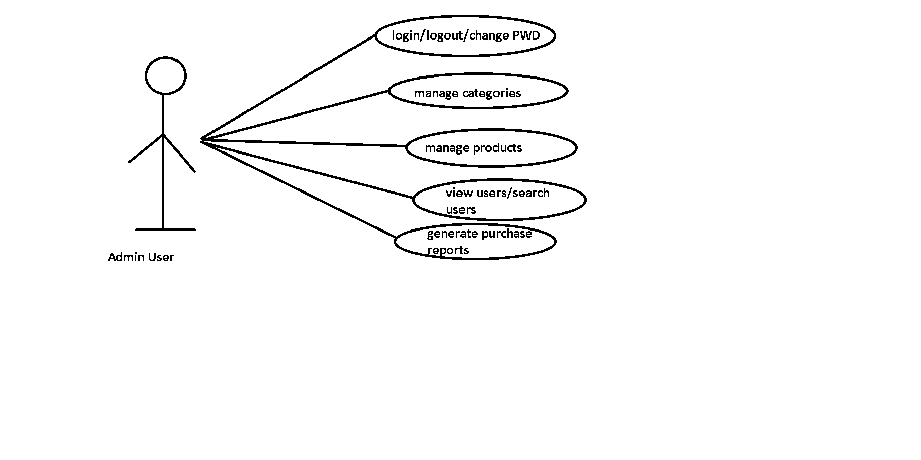

List out Entities

Admin-loginid, password

User- userid, password, phone, address, fname,lname,email

Product- id, name, price, cat_id, description

Category- id, name , description

Order- id, date, paymentmode, pid, uid

Api end points needs to be created from Admin perspective.

1. Login/Logout/Change Password

1. localhost:8080/admin/login ---> pass userId and password as request body --> of correct credentials --> Status OK else --> Not_Found

2. localhost:8080/admin/login --> PutMapping

apply logic to change password

3. localhost:8080/admin/logout --> status OK.

2. Manage Categories

Create entity

Repo

Service

Controller

Write method to add, update, delete and find all categories

Localhost:8080/admin/categories

3. Manage Products

Create entity

Repository

Service

Controller

Write methods for add, update, delete and find all products

Localhost:8080/admin/products (get/post/put/delete)

4. Manage Users

User entity

Repo

Service

Controller

Create method to getAllUsers and findById or findByName

(view all and search functionality)

Localhost:8080/admin/users

Localhost:808/admin/users/{userId}

5. Generate Purchase Report

Purchase Entity

Repo

Service

Controller

(getPurchaseByDate and getPurchaseByCategory)

|  |  |  |  |  |  |
| --- | --- | --- | --- | --- | --- |
| Id | Product_id | Customer_id | date | amount | category |
|  |  |  |  |  |  |
|  |  |  |  |  |  |
|  |  |  |  |  |  |
|  |  |  |  |  |  |
|  |  |  |  |  |  |

Localhost:8080/admin/purchase/genreport